What is O Data? ** W
- OData (Open Data Protocol) is a REST-based protocol used to expose and consume data from SAP systems. It allows communication between SAP (like SAP Gateway) and external systems (UI5, Fiori, mobile apps, etc.) using standard HTTP methods.
- Data is a web protocol based on REST, for querying and updating data.
- Applying and building on web technologies such as HTTP, Atom publishing protocol (Atom pub) and RSS – Really simple syndication
- Provide access to information from variety of applications.
- data is combination of two essential parts 1. Format – Define how data described
2. Protocol – Define how data is manipulated.
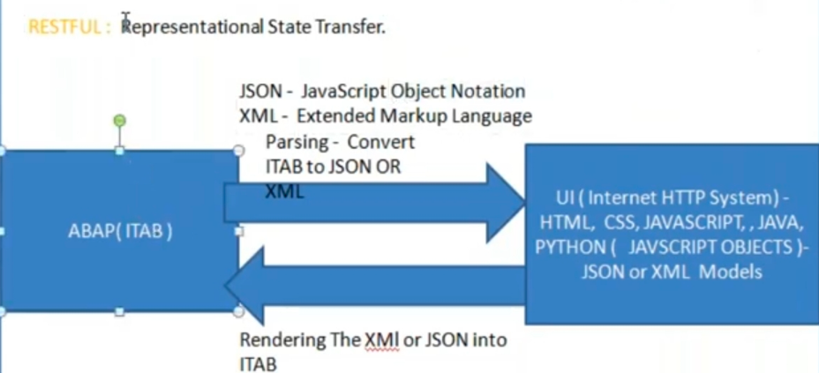
Difference between OData and REST API?
OData is a standardized protocol built on REST architecture. It provides metadata ($metadata), query options ($filter, $select, $expand), and uses XML/JSON formats. REST is a general architectural style without a fixed standard
Main components of an OData service? ** W
- Data Model (Entity Types & Sets, Associations)
- Service implementation (Operations details e.x, Create, Get, Update entity)
- Runtime Artifacts (DPC & MPC classes)
- Service maintenance (/IWFND/MAINT_SERVICE)
CRUD operations in OData?
Create (POST), Read (GET), Update (PUT/MERGE), Delete (DELETE)
What is $metadata? **W
Meta data in Odata service defines properties, relationships & entities exposed via $metadata URL.

Where is the origin of O Data?
- Weblogs, blogging and syndication
- Rich site summary
This over all structure like a document, with a header and items.
RSS is also known as Really simple syndication.
What is API? *
API are mechanism that enable two software components to communicate with each other using set of definitions and protocols.
What are the different types of API?
- Soap API: XML, used in past
- RPC API : Remote procedure calls
- Websocket API : Used JSON objects, Two way communications
- Rest API : Most popular
What rules API should follow?
- Uniform interface: Client receive information about all other related resources they need to complete a task. The server achieves this by sending hyperlinks in the representation so that client can dynamically discover more.
- Statelessness: Statelessness refer to a communication method in which the server completes every client request independently of all previous requests.
- Layered system: Client can connect to other authorized intermediaries between the client and server and it will still receive responses from the server.
- Cacheability: Process of storing some response on the client to improve server response time.
- Code on demand: Transferring software programming code to the client.
What is remote API and Web API?
- Remote API are designed to interact through a communications network.
- Web API are communications through network.
What is URI? *
Unique resource identifier URI = URL – location + URN -Name.
https://services.odata.org/ + v4/northwind/
What is the restful API server response message? * W
- 1xx – Information – processing 102
- 2xx – Success – Ok 200, Ok created 201
- 3xx – Redirection – Moved to new URL 301
- 4xx – Client side error – Bad request 400
- 5xx – Server side error – Not implemented 501.
What is gate way add on in O data configuration?
- GW_CORE – O data libraries
- IW_FND – Run time component, Metadata store, Shared services.
- IW_BEP – Business enablement provisioning
- IW_HDB – Business content adaptor for SAP gate way with SAP HANA to enable exposure of SAP HANA views.
What is the core component for SAP gate way foundation?
- SAP Netweaver below 7.4
Register and maintain O Data service: GW_CORE, IW_FND
To develop the O data service: IW_BEP – Business enablement provisioning
- SAP Netweaver 7.4 higher
Develop, Register and maintain O data service SAP_GWFND
GW_CORE – O data libraries
IW_FND – Run time component, Metadata store, Shared services.
IW_BEP – Business enablement provisioning
IW_HDB – Business content adaptor for SAP gate way with SAP HANA to enable exposure of SAP HANA views.
What are the deployment option available in O Data? ** W
- Central hub deployment
- Embedded deployment
What is central hub deployment?
What is embedded deployment?
What is the advantage and disadvantage of central hub deployment?
Advantage
- Routing and composition of multiple system is supported.
- Dedicated SAP gateway foundation content is available
- Decoupled life cycle of customer applications from the SAP business suite system.
- SAP gateway foundation cachablities need to be deployed only once with in the landscape.
- Single point of access to backed system.

Disadvantage
- Enhanced security because of no direct access to backend system.
- Independent innovation speed of SAP gateway foundation and the connected SAP business suite systems.
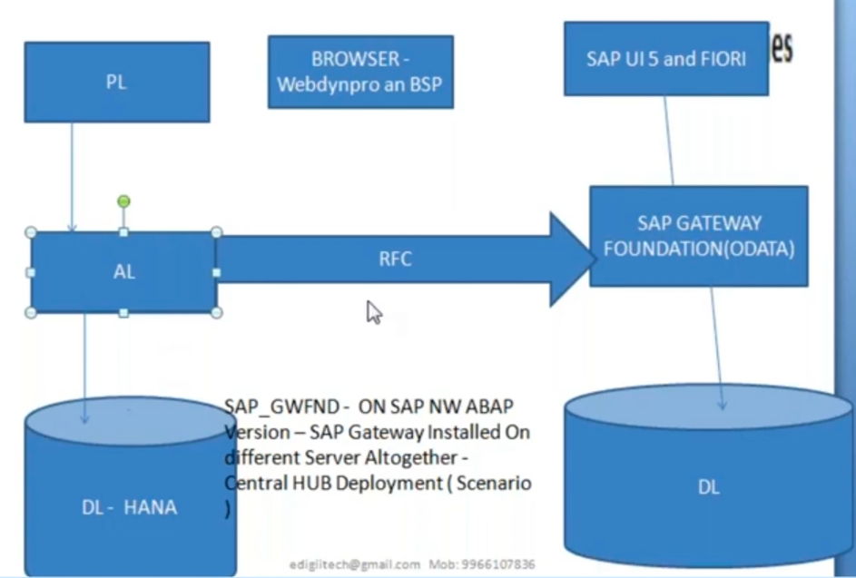
What is the advantage and disadvantage of embedded deployment? * W
Advantage
- Less runtime overhead as one remote call reduced.
- No additional separate SAP gateway foundation system required.
- Lower total cost of ownership as there is one less system to maintain.
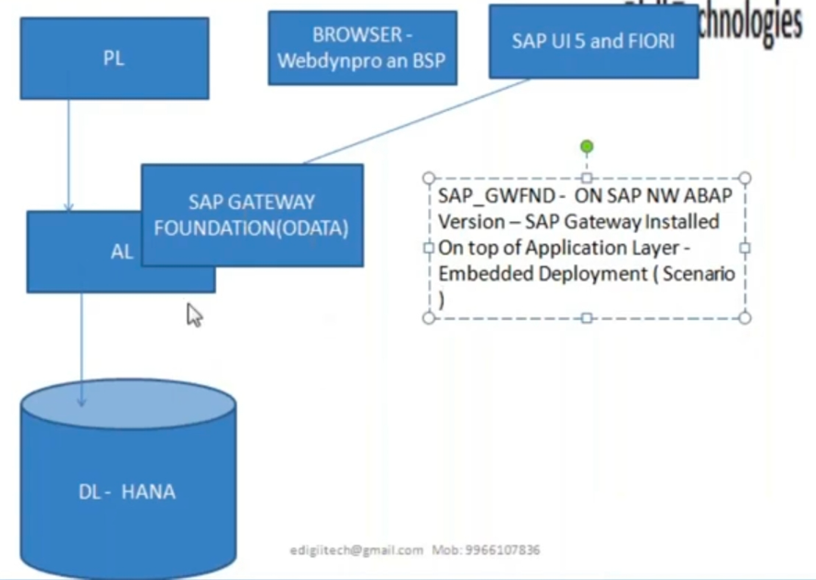
Disadvantage
- The innovation speed of SAP gateway foundation and the SAP Business system need to be synchronized.
- Cross system composition is not advisable.
- Central SAP gateway foundation content is not available, content specific to SAP business suite is used in SAP business suite system.

What is difference between Entity Type vs Entity Set ? ** W
We use entity set as business operations. Entity Type represents a single data record (like structure). Entity Set represents a collection (like table rows). It is blue print of business entity, It provide metadata of the business entity.
What are the Main DPC_EXT methods? ** W
CREATE_ENTITY, GET_ENTITY, GET_ENTITYSET, UPDATE_ENTITY, DELETE_ENTITY.
What is the use of $filter and $select usage? * WH
$filter = to filter data. Example: /SalesSet?$filter=CustID eq '1001'. $select = to fetch specific fields. Example: /SalesSet?$select=SalesID,Amount.
What are the option in create a project type? ** W
- #Service with SAP annotations: SAP annotations include create, update, label, unit property. You can also define the null, default, Max length, precisions, scale, the ABAP type information available includes ABAP field name and ABAP type editor.
- Service with vocabulary-based annotations: It is not available for project type. In this case terms can be consolidated in a vocabulary and uploaded into the vocabulary repository.
- Annotation model for referenced service: If you want to annotate an artifact of an existing service without modifying the service and provide the additional information about the artifacts. You can import another service as a reference in read only mode and then create annotations.
- V4
#What is associations in OData? ** W
Associations are defined relationship between two or more entity types.
#What is navigation properties in O Data? ** W
Navigation property is a special property in an entity type that links it to another entity type based on association ( relationship ). It stores how entity related.
Special properties on entity types which are bound to a specific association and can be used to refer to associations of an entity.
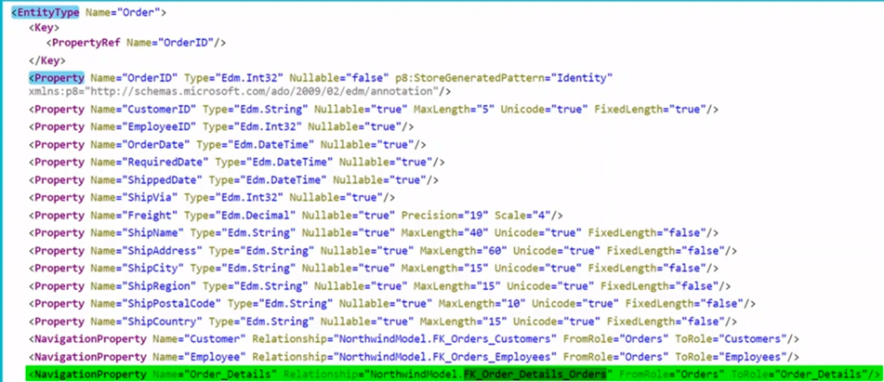
Where will see associations in XML?
In navigation properties: Special properties on entity types which are bound to a specific association and can be used to refer to associations of an entity.
What is expand query option in O Data? ** W
O data query option $ expand is used to read multiple entity sets in a single service call instead of two different calls. Expand is used to display a header and item data in one call.
?$expand=Items&format=json.
Explicit implementation is not required to use $expand query option
What is Expand? * W
- Expand / Deep insert for associated entity types when you need to fetch or create deep data.
- Expand is the possibility of OData to make ‘Joints’.
- Deep insert are the possibility to make updates on views.
- $Expand / Deep insert for more data which contains more than one association call.
Advantage: Expand implementation can reduce the SAP business suite times, because the number of database operations and the application logic can be reduced.
URI queries Note: Items is name of the navigation properties
Method – Get_expanded_entityset
For expand option( Get all header & Item ) – entityname?$expand=Items + Get
For expand entity( Get all header & Item ) – entityname(‘1233’)?$expand=Items + Gt
CRUD
For create entity set use in DB – entityname + Post
For create entity use in DB – entityname + Post
For update entity use in DB – entityname(‘1233’) + Put
For delete entity use in DB – entityname(‘1233’) + Delete
What is main difference between navigation and expand query? ** W
Both are used to access related ( associated ) data but they work differently. Navigation retrieves related entity data in a separate request, while $expand retrieves the main entity and its related entities together in one request.
What is Deep Entity? ** W
Deep entity is a method used to create or update parent and child entities in one call (nested data) but main difference between expand is used to read associated entities in single get request, where as deep entity is used to create or update parent and child entities together in one post/put.
What is Batch request in OData? ** W
All the operations which need to be performed put in one payload and submitted as a single HTTP post request.
Used to execute multiple OData operations in a single HTTP request.
Trigger URI - $batch
Payload:
--batch_01
Content-Type: application/http
Content-Transfer-Encoding: binary
Get LBG_HeaderSet HTTP/1.1
--batch_01—
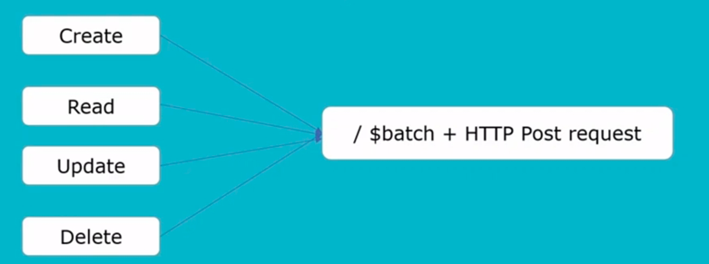
What is batch parallelization? * W
Only the GET request will be executed in parallel. Number of maximum parallel processing request will be voided in the available work process in system is low for parallel processing.
T.Code: /IWBEP/CONF_SERVICE, /IWFND/MAINT_SERVICE.
E.X
3 Get, 2 Post, 1 Put, 1 Delete
#What is batch change set? ** W
A batch change set is a part of an Odata batch request that contains one or more CUD operations. Create, Post, and Delete etc. operations.
The change set internally are handled by 2 API methods
CHANGESET_BEGIN – by default allows only 1 operation per change set.
CHANGESET_END – Finalization of modification updates occurs here, the framework issue a commit work at the end of this method.
Points to remember
We can use one or more update/Delete/Insert operation within a ‘Changeset’ make sure there is no commit work statement within any one Update/Create/Delete entity. If it exist the system will dump the request and no further processing will happen.
If an operation within a changeset fails, the batch response body contains only one single response for this changeset indicating the failure of the entire change set. Change set process will be single LUW.
Every change set is treated as separate LUW ensuring the ‘Nothing’ transaction behavior.
If there are 2 change sets with some operations within it that implies processing of two LUW.
What is the performance use using the batch?
To send the data of several request in a single HTTP request from the client to the SAP gateway server for entity types are not associated:
Do use parallel calls in case of two read calls or two update calls with multiple atomic units of work (Different change sets). As an alternative to two parallel calls, you can considered using $batch
Do use $batch in case of more then two calls without associated entity types (Do not make too many client – SAP gateway server round).
Consider the balance between the number of roundtrips and the payload size. A payload size which is too big can affect the network time due to bandwidth constraints.
Considered using batch because it can have a negative impact on the response time since SAP gateway calls SAP business suite in sequential order ( In case of read calls or update calls with multiple units of work).
What is the advantage of using batch? *W
Batch reduce the number of roundtrips between the end user and the SAP gateway server. As a result network time is reduced.
Batch reduce the number of round trips from the SAP gateway server to the SAP business suite to one in case of update calls with a single atomic unit of work.
Batch reduces SAP gateway server response time and the consumption of resources.
Batch reduces CPU time of the SAP business suite in case of update calls with a single atomic unit of work.
#What is batch defer mode? **W
Batch defer mode in Odata allows multiple change operations to be deferred and executed together in a single transactional $batch request.
SAP 740 SP09 batch processing, performance has been improved by introducing new API for changeset processing in defer mode.
The defer mode processing is introduced to achieve performance by handling multiple operations within a change set.
For e.x if you make defer mode = ‘X’ it will not call delete, modify, update, create, get entity not triggered by change set.
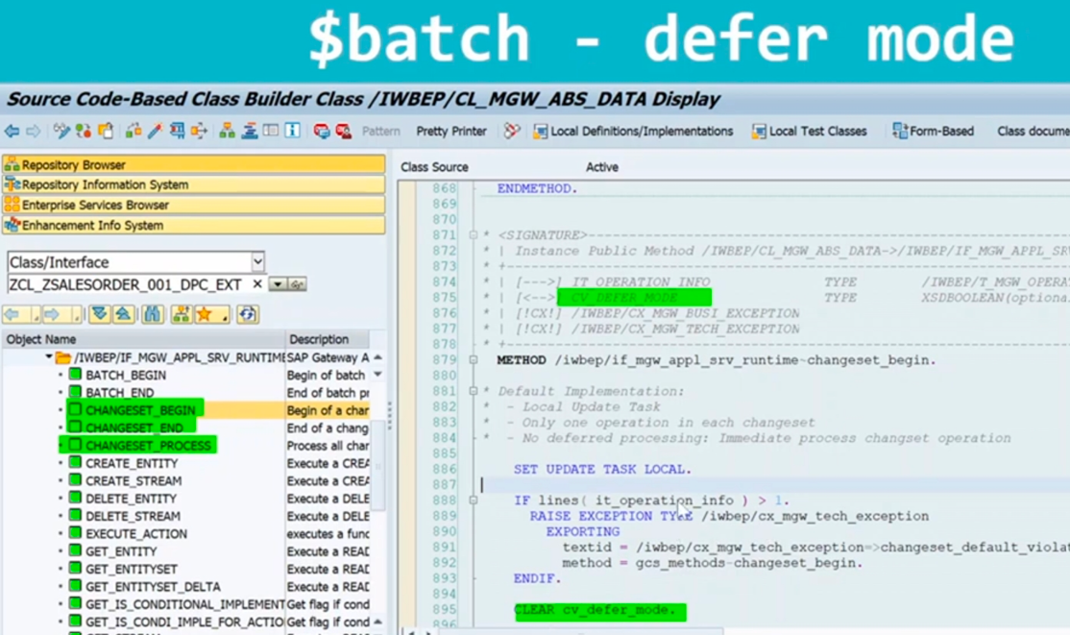
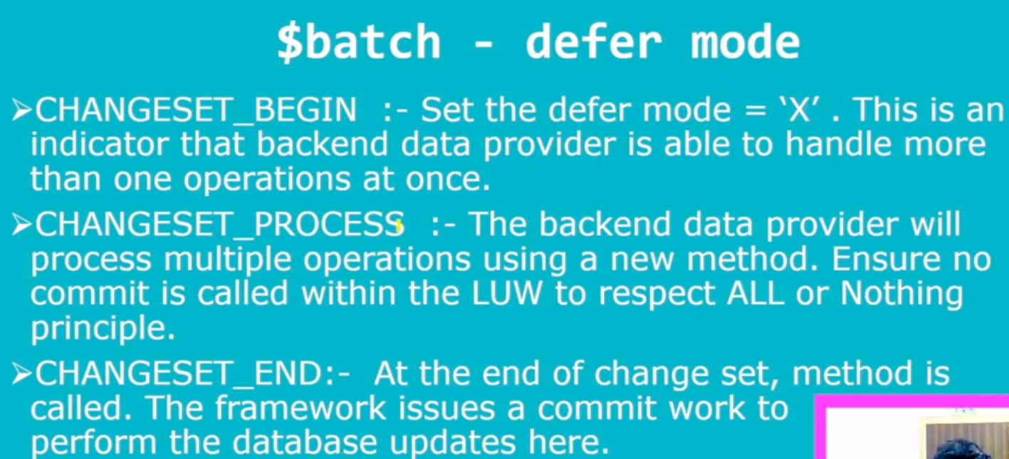

Based on the situation which one you select expand or batch chart listed below
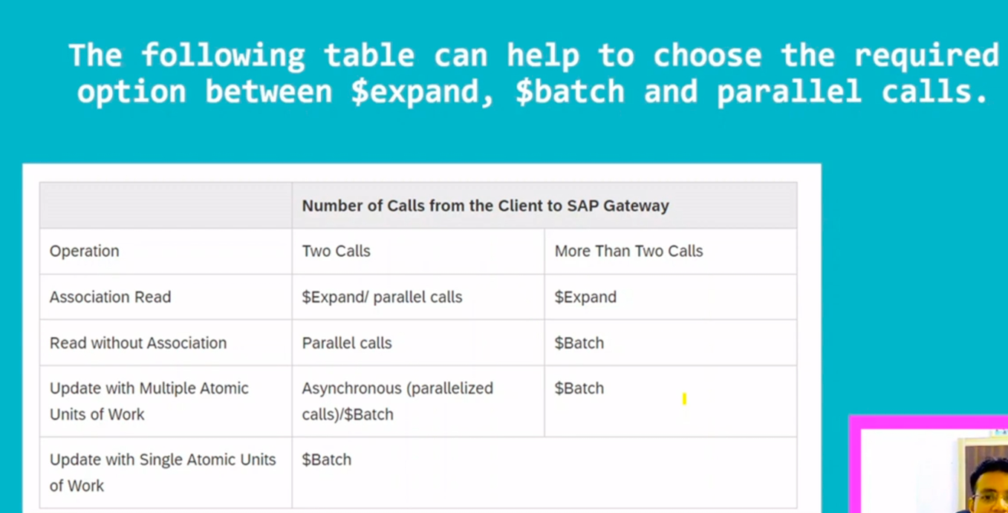
What is difference between client side paging and server side paging? **W
Client side paging: The client decides how many records it want to load and asks the server that many records. That achieved by using $skip and $stop query options.
Server side paging: In server side paging, even if the client requests all the records, the server will only return all the records, the server will only return a portion of the result.
Server provide a ‘next link’ information, which can be followed to get the next portion and so on.
This we can achieve by using $skiptoken query option.
What is function import in OData? **W
Function imports may be used for operations other than CRUD, such as approve, reject, reserve and cancel.
Anything that cannot be mapped to the standard CURD operations we do through function imports.
For ex.
- Confirm work item
- Check flight availability
- Get sales order status count
- Release, Approve PO/SO.
Do Don’t do in function imports?
Don’t use HTTP method name (Such as Get as prefix, surfix or infix), For example, Get product by rating Do use Products By Rating.
Do use appropriate HTTP method. A Get method must have a return type. Post should have parameters.
If you find yourself inventing function imports such as create X, Read X, Get X, Change X, Update X, or Delete X you should make the entity type X part of your model.
What is media handling in Odata? ** W
Media handling in Odata is used to upload, download and manage large binary data (files) such as PDF, images, videos, excel files etc…
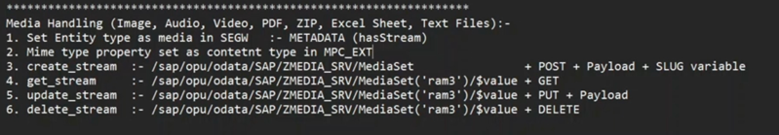
What is concurrency control?** W
Accessing / Updating a resource at same time by different users. It causing confusion among the users and inconsistency in the expected output. Such situation handled by concurrency control.
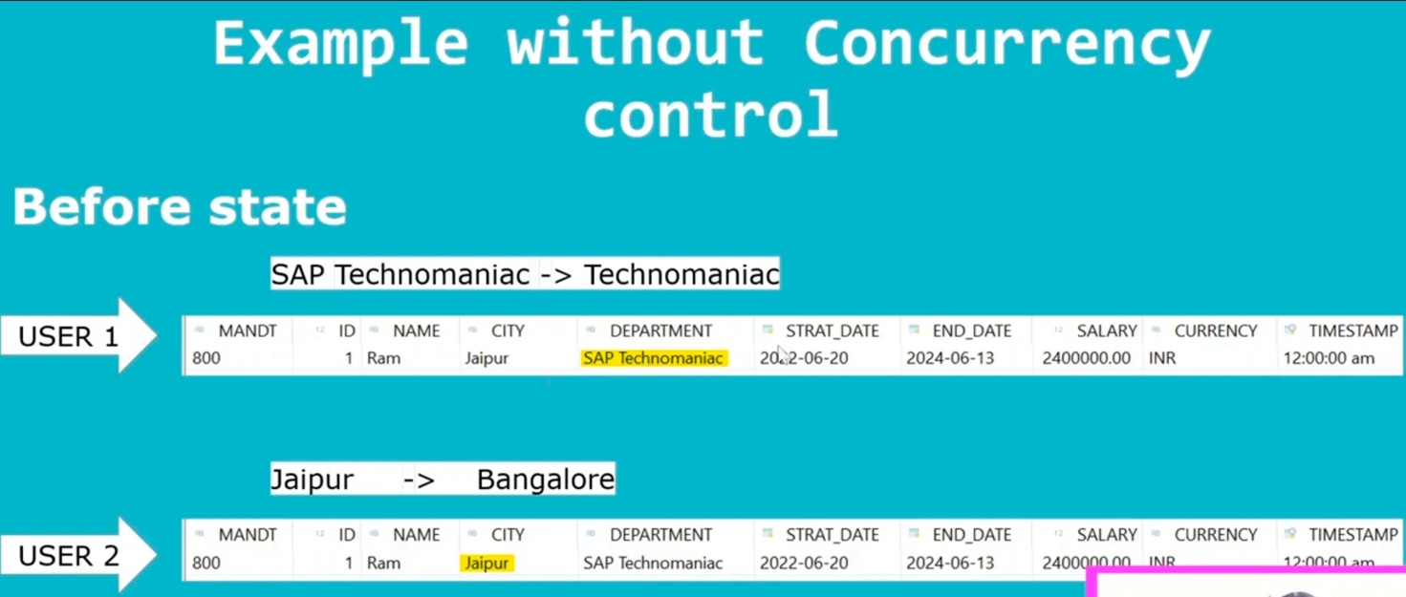
Concurrency control types,
- Pessimistic concurrency control
- Optimistic concurrency control
- Semi-optimistic concurrency control
What us pessimistic concurrency control?
Pessimistic concurrency control assumes that conflict between transactions can happen often and blocks data records when a user starts happen offen and block data records when a user starts to update. So other users will not be able to update that data until the lock is released.
In this scenario the application assumes that concurrent writes will occur so often and hence we need to aggressively protect w/o being edited by multiple requests at same time using pessimistic locks.
This is normally involve a performance reduction. Dead lock can occur.
What is optimistic concurrency control?
In this scenario the application assumes that the like hood of a concurrent write is rare and allow operations to continue and lock resources for very small period of time. So all the operations in the transaction are attempted and rolled back if one fails.
What is semi optimistic concurrency control?
This is blend of the pessimistic and optimistic concurrency controls.
It is possible to get higher throughput by managing the resource look individually.These are normally for very specific use.
What are the potential problems in concurrency?
Lost updates occur when multiple transaction select same roe and update the row based on the value selected.
Second transaction selects a row which is updated by another transaction (Dirty read ).
Second transaction is trying to access the same row several times and reads different data each time.
What is Etag – Entity tag? **
Etags are usually timestamps that are update when entity is updated.
Etags are part of the HTTP protocol, they are higher fields that help to determine changes of a resources.
For more complex scenarios however, timestamps might not be the best choice and a hashtag is the better approach.
What are the ways to built Odata service? **
1.ABAP code based service implementation.
2.Service adaptation description language(SADL) framework.
- Referenced data source/Mapping error.
- Annotation based approach (Odata.Publish : true)
CDS + BOPF
CDS + RAP
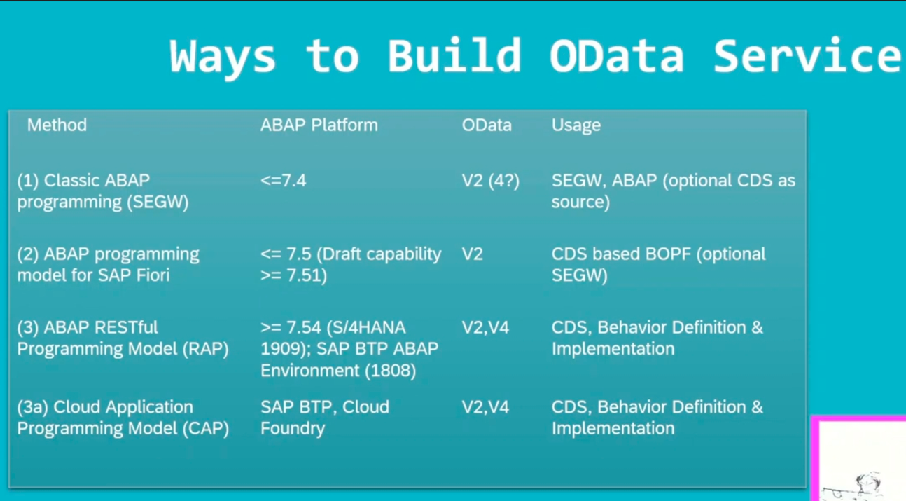
What is O data service t.code?
SEGW
What is Etag code based approach?
It is generic approach we just go to entity type and give Etag a property.
Generic frame work support does not require any codeing but it requires that the Get_entity method has to be implemented code based implementation.
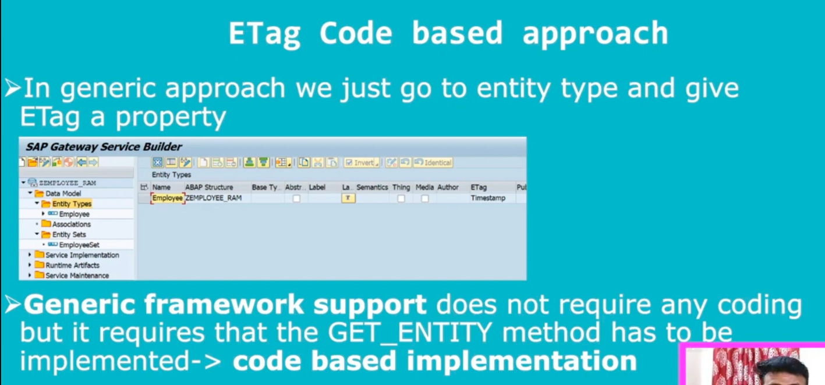
What is RDS Etag?
When we create Odata service with reference to cds using RDS approach this Etag property is not editable so generic approach will not work here we have to do code based approach.
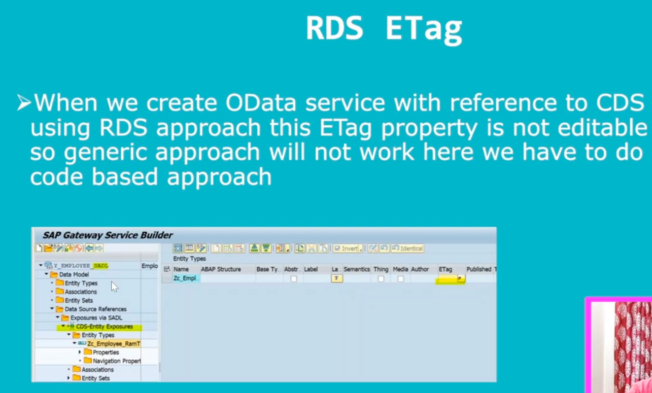
What is advantage of Etag code based approach?
When using the out of the box framework support this is not possible and we cannot be 100% sure that another user has updated the data in the short timeframe between the read request of the framework and your update request. ( This have some advantages since it allows the developer to lock the data while the etag before the update is performed ).
The second advantage is that a code based implementation also offers etag support for function imports.
What is use of RFZ10 t.code ?
What is use of STRUST t.code?
What is use of SMICM t.code?
How to activate the O Data service?
What all the T.Code using O data? ** W
/N/IWFND/ERROR_LOG – To find the error log after we execute a URI or you click error icon in same screen.
/N/IWFND/CACHE_CLEANUP – Clean the cache files
IW_BEP = SEGW or SAP_GWFND
GW_CORE
/N/IWFND/MAINT_SERVICE – Maintain Odata service
/N/IWFND/GW_CLIENT – SAP Gateway

